Course: Securing and Integrating Components of your Application

Module 3: Adding intelligence to your application

Intro

* Machine learning (ML) = pattern recognition by machines
* Google provides pre-trained ML models
  + categories: vision, speech, natural language processing and video intelligence
  + use APIs
  + add intelligence to your application

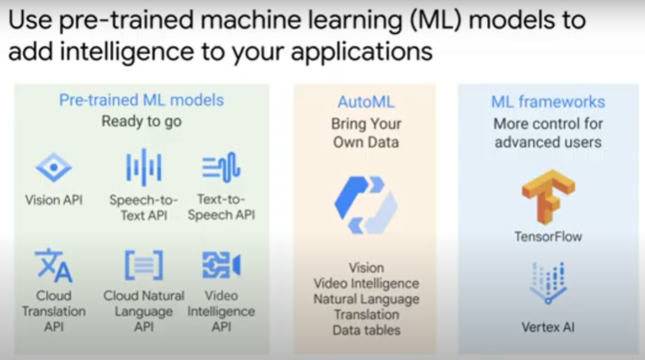

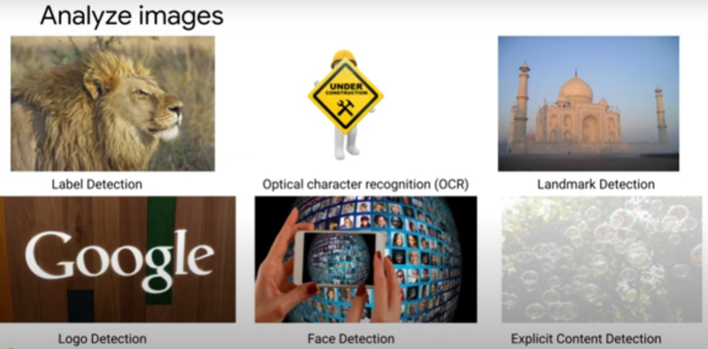Cloud Vision API

* detect and categorise objects
* can detect logo, landmark, faces and explicit content
* OCR text

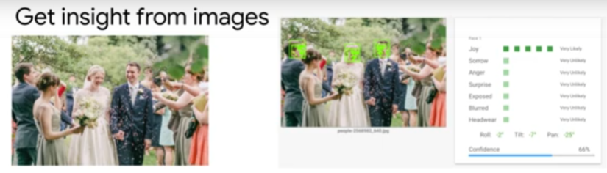

example: analyze face and get info on emotion expression (joy) and headwear

Cloud Speech-to-Text

* 125 langauges
* use case examples:
  + Interactive Voice Response (IVR) of helpline. Improve customer service by performing analytics, e.g. sentiment analysis, of transcribed audio files.
  + voice control of IoT devices/sensors
  + captions and subtitles on videos

Cloud Video Intelligence API

* recognise 20k+ objects, places, actions
* at video, shot or frame level
* use case examples:
  + video content moderation
  + recommendation engine using labels with user’s history and preferences
  + contextual advertisements
  + use case example: At Google, to detect conference room usage. Problem: book room, but not use. Those who really need, don’t have available room.
    - Video conference camera detects motion.
    - Caller ID identifies occupants.
    - Camera sends Pub/Sub notification every 30s whether motion detected, and when call starts/ends.
    - If motion detected 6-8 minutes after meeting start time, it counts as occupied.
      * Otherwise, room is released for use by others.



Cloud Translation API

* localise content for industry slang or domain-specific terms
* near real-time translate from source to target language
* for websites, social media, applications and documents

Cloud Natural Language API

* text analysis
* recognise and classify entities (e.g. person, location, event) in text

Customs models

* use own data to train ML models using TensorFlow and Vertex AI.

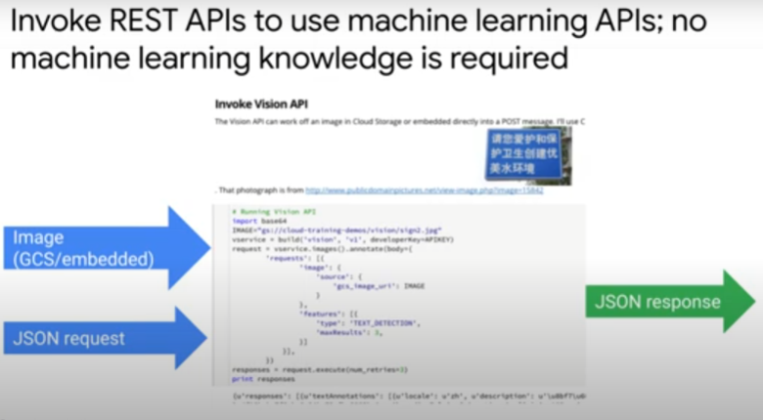

To implement AI in applications, only need to invoke REST APIs

* No need to know how to build ML models
* example: image in Google Cloud Storage. Invoke Vision API -> send it a Json request -> receive Json response with attributes of image.